Participating in a Discussion Board
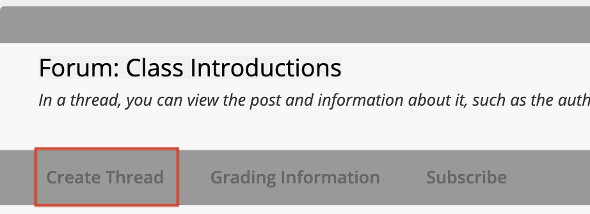
To add a new thread to a discussion forum, click the Create Thread button.

Some discussion boards will require that you create a thread before you view your classmates’ posts. If this is the case, click the Create Thread button.

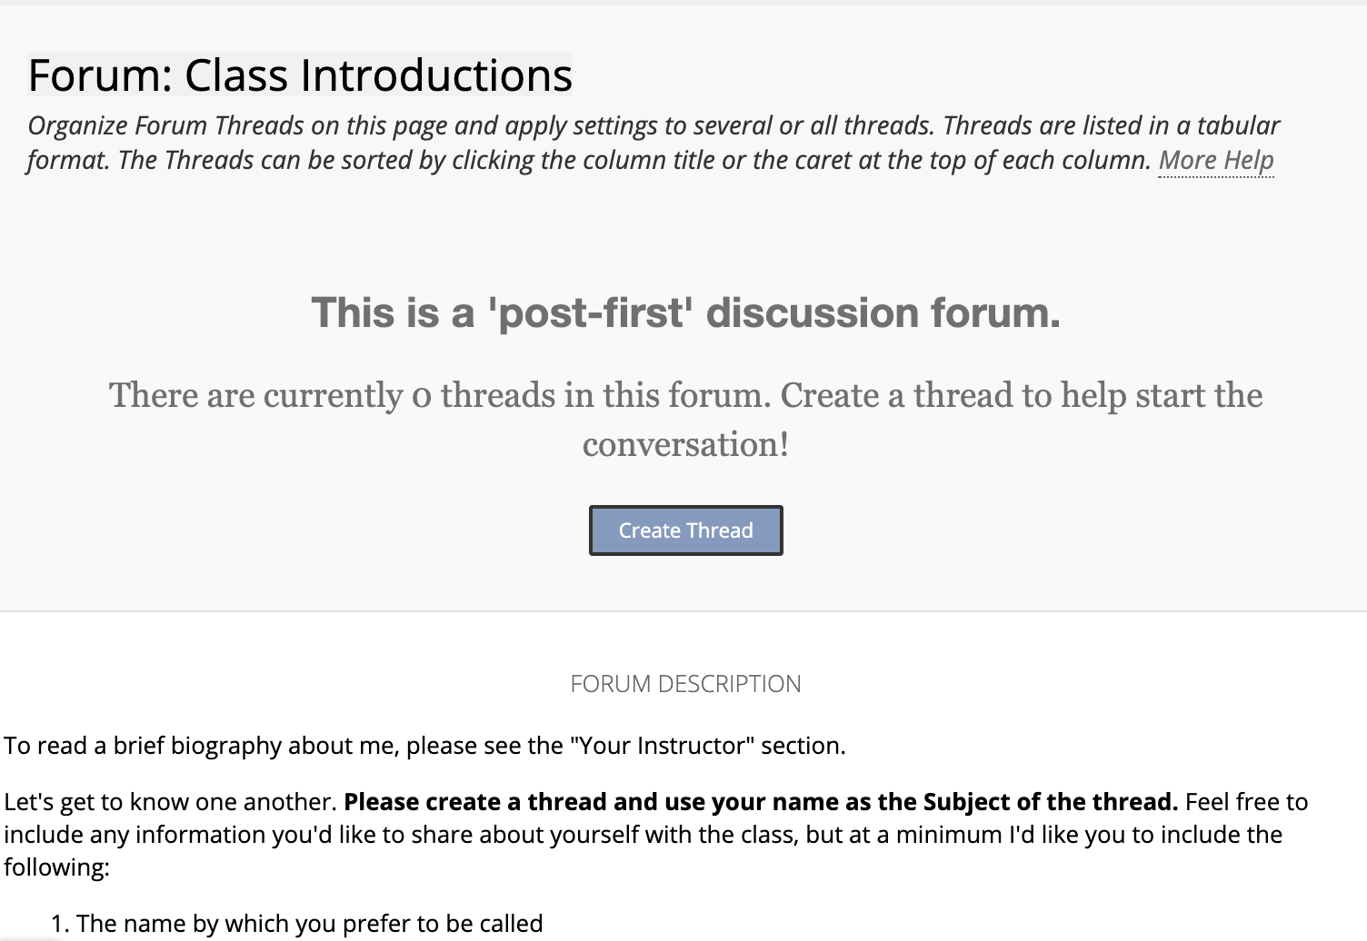

The forum description will be available for you to reference as you create your post. You will add your own response below the description.

Enter a subject for the thread. The subject should be concise yet descriptive. In the message area, add your response or answer(s) to the forum to fulfill the requirements.

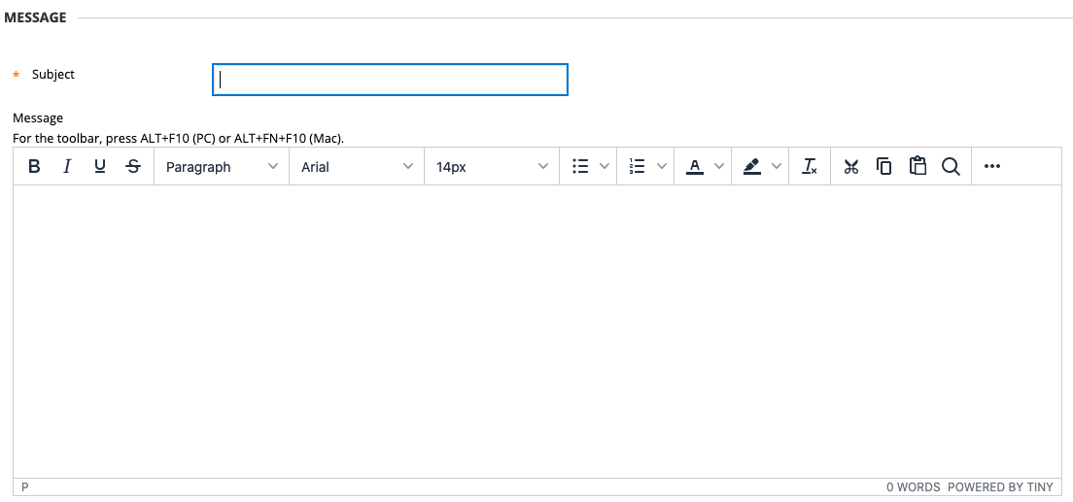

If you typed your response in Microsoft Word, at this time, you can paste it into the message box. First, highlight all of the text in Word, go to Edit in the menu (top of screen), and select Copy.

Note: The Copy keyboard shortcut on Windows is Ctrl + C and on Macs is Command + C.

Next, go into the discussion forum in Blackboard and click your cursor into the Message box. If your text editor toolbar has limited icons, click the three dots button.

This will expand the text editor, revealing more buttons. You will see an icon that looks like a clipboard with a piece of paper over it. Click this and your copied text will appear.

Note: The Paste keyboard shortcut on Windows is Ctrl + V and on Macs is Command + V.

You can also type directly into the message box.

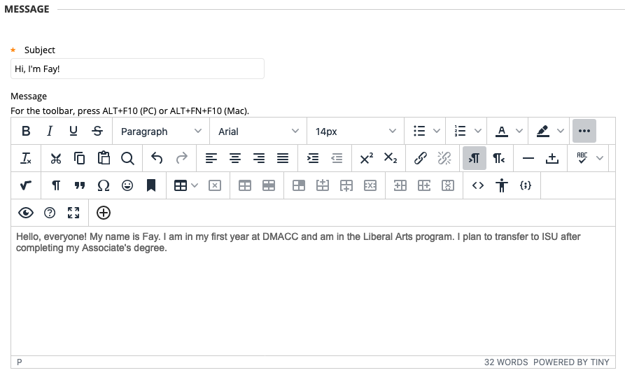
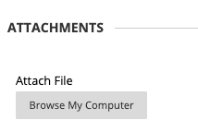
If your instructor has enabled it, you can attach files to discussion boards. To attach a file, select the Browse My Computer button and find your document and select it to attach.

When your message is complete, click Submit.

Note: Depending on your instructor’s settings, once you press Submit, you may not be able to edit your post again, so make sure it is ready to be public.

To reply to a post, click the thread title to open it. Then select the Reply button in the message box, located under the post.

You may also choose to reply with a Quote, which will copy the previous post into the body of your new message. The quote button will appear when you bring your mouse next to the Reply button.

After you press the reply button, the other responses will shift down and you will be provided with a textbox to type your response.

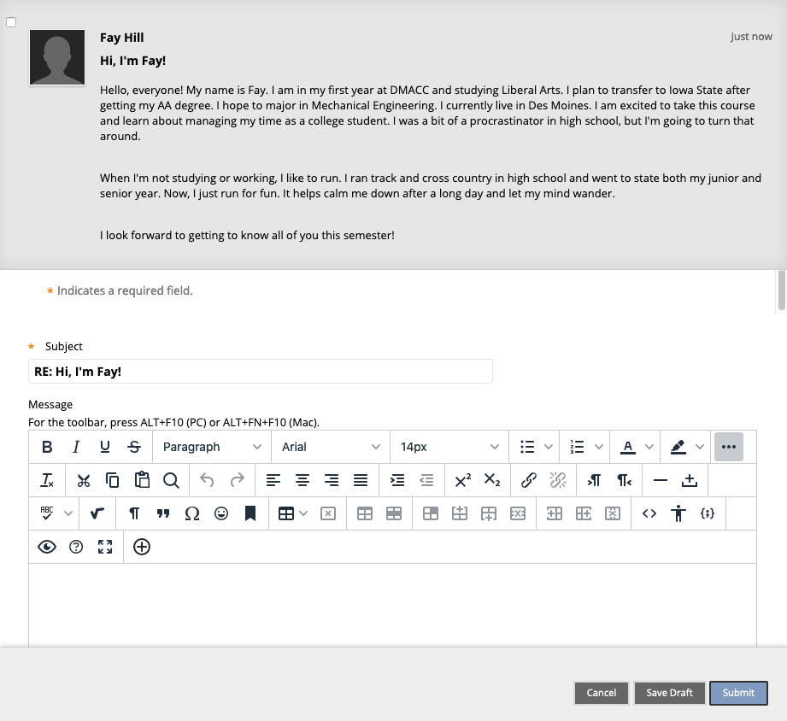

When you are finished with your reply, click Submit.

You will then see your response listed at the bottom of the page. Click OK to return to the main discussion forum.

This concludes the basic introduction to using Blackboard Discussion Boards.

